

**Kaius Resources**

**Standard Operating Procedure – Manual Handling**

Reference: SOP-010

Table of Contents

1. Purpose 3

2. Scope 3

3. Authority 3

4. Responsibilities 3

5. Definitions and Abbreviations 5

6. Procedure 5

6.1 Introduction 5

6.2 Risk Associated with Manual Handling 6

6.2.1 Occupational Overuse Syndrome 6

6.3 Assessment of the Risks Associated with Manual Handling 6

6.3.1 The Task 6

6.3.2 The Load 7

6.3.3 The Individual 7

6.3.4 The Working Environment 7

6.3.5 Use of PPE 7

6.4 Controls for Managing the Risks Associated with Manual Handling 7

6.4.1 Elimination of Hazardous Manual Handling Activities 7

6.4.2 Engineering or Mechanical Assistance 8

6.4.3 Storage Arrangements 8

6.4.4 Housekeeping 8

6.4.5 Use of PPE 8

6.4.6 Weight Limits 8

6.4.7 Training in Manual Handling Techniques 8

7. Review Criteria 9

8. Safety and Environment 9

9. Attachments, References and Related Documents 9

9.1 References and Related Documents 9

Appendix A Safe Lifting Technique 10

# Purpose

This Standard Operating Procedure outlines the requirements for safe manual handling practices.

# Scope

This Standard Operating Procedure (SOP) applies to all activities at sites operated and/or under the control of Kaius Pty Ltd and its subsidiaries. It applies to all persons working on the site including exploration personnel, permanent, temporary and contract employees. This SOP forms a key part of the Kaius Safety & Health Management System which has been established to manage risk to an acceptable level and in accordance with all relevant legislation.

# Authority

This procedure can only be altered with the approval of the Site Senior Executive (SSE).

# Responsibilities

**Site Senior Executive (SSE)**

Site Senior Executive shall ensure:

* That all of the provisions of this SOP are implemented and that compliance is achieved.
* Adequate resources are provided to maintain compliance with the requirements of this SOP, and
* The application and requirements of this SOP are periodically audited and reviewed.

**Supervisors**

Supervisors shall ensure:

* That the requirements of this SOP are implemented.
* That workers, including contractors, are trained in the requirements of this SOP.
* All work undertaken within their area of responsibility is conducted in accordance with the requirements of this SOP.
* They monitor compliance with this SOP.
* This Standard is readily available to all workers and contractors.

**Mine Workers**

Mine Workers shall:

* Undertake the training and assessment provided by the SSE.
* Act in accordance with this SOP, and
* Not undertake any tasks for which they are unable to safely complete.

# Definitions and Abbreviations

The following definitions and abbreviations are used in this procedure.

|  |  |
| --- | --- |
| CMSHA | Coal Mining Safety and Health Act (1999) |
| CMSHR | Coal Mining Safety and Health Regulation (2017) |
| Competent Person | A person who has the necessary training, skills, and capability to carry out the task |
| Shall | Indicates that a statement is mandatory |
| Should | Indicates a recommendation |
| Manual Handling | Use of a person’s physical strength to move, lift, or support objects. It also includes the use of handheld tools |
| OOS | Occupational Overuse Syndrome |
| PPE | Personal Protective Equipment |
| RSI | Repetitive Strain Injury |
| SOP | Standard Operating Procedure |
| SSE | Site Senior Executive |
| KRES | Kaius Mine |

# Procedure

## Introduction

Before undertaking any manual handling task, workers shall:

* Consider the level of risk associated with the task, and
* Satisfy themselves that the necessary controls are in place.

Injuries from manual handling may not appear at the time of the task but can occur over a period of time. This damage can result in musculoskeletal pain, sprains, strains, lack of feeling, restriction of movement or injury such as a hernia.

Workers are not to attempt any manual handling activity that is outside their capabilities to perform safely. When there is any doubt, assistance or further advice is to be obtained before commencing the task.

## Risk Associated with Manual Handling

Risks associated with manual handling can include:

* Handling loads - frequent lifting with the back bent and/or twisted or pushing or pulling loads.
* Repetitive work - using the hand or arm, or gripping tools or loads tightly.
* Static work of the whole body - working in a fixed position with the back bent, continuous sitting or standing, or driving vehicles for long periods.
* Static work of the upper limb - working with the neck, shoulders, and arms in a fixed position (such as using tools and handling heavy loads), and
* Vibration – using tools or coming into contact with vibrating surfaces while undertaking manual tasks.

### Occupational Overuse Syndrome

Occupational overuse syndrome (OOS) also known as repetitive strain injury (RSI) is a collective term for a range of conditions characterised by discomfort or persistent pain in muscles, tendons, and other soft tissue, with or without physical manifestations.

OOS is usually associated with manual handling tasks that involve:

* Repetitive or forceful movement.
* Maintenance of constrained or awkward postures.
* Extremes of joint range, and
* Fatigue.

## Assessment of the Risks Associated with Manual Handling

Where tasks are identified that are routine and involve manual handling risks, they should be assessed by the person before starting the task.

Non-routine or unusual tasks should be assessed by the workers involved considering the following factors: (Take 5 should always be conducted prior to any such task)

* Task
* Load
* Individual
* Environment, and
* PPE.

### The Task

* Incorrect posture to lift a load significantly increases the risk of a back injury.
* Where possible, items should be lifted from no lower than knee-height to no higher than shoulder height - outside this range, lifting capacity is reduced and the risk of injury is increased.
* When items are required to be lifted from above shoulder height, a stand or suitable means of access should be used.
* Items which are pushed or pulled should be as near to waist level as possible. Pushing is preferred, particularly where the back can rest against a fixed object to give leverage.
* Carrying distances should be minimised.
* Repetitive tasks should be avoided whenever possible.
* Tasks which involves lifting and carrying should be designed in such a way as to allow for significant rest breaks (rotation of tasks) to avoid fatigue.
* Tasks that require twisting the body should be avoided wherever possible.

### The Load

* The load should be kept as close to the body as possible.
* It should not be large enough to block vision.
* An indication of the weight of the load and the centre of gravity should be provided where appropriate. Unstable loads should be handled with particular caution. The change in the centre of gravity is likely to result in over balancing.
* Ensure there is a secure hand hold, using gloves where necessary to protect against sharp edges or splinters.

### The Individual

* Consideration shall be given to age, body weight and physical fitness of the worker. Workers shall not attempt to handle those loads that are beyond their capability.
* Assistance shall be sought if considered necessary. This may be using two people to complete the lift or using mechanical assistance.
* Knowledge and understanding of the work is an important factor in reducing the risk of injury.

### The Working Environment

* There shall be adequate space to enable the activity to be conducted in safety.
* Lighting and weather conditions shall be taken into account.

### Use of PPE

* The use of personal protective equipment may be necessary. If the use of personal protective equipment restricts safe and easy movement, this shall be considered.

## Controls for Managing the Risks Associated with Manual Handling

### Elimination of Hazardous Manual Handling Activities

Where possible, the operations which involve manual handling should be eliminated. The measures to achieve this include:

* The ergonomic design of the workplace and activity e.g. change to lighter materials or smaller quantities. Ensure materials are ordered with suitable handles on packaging, and
* The provision of automated or mechanical aids such as trolleys, wheelbarrows, or other lifting equipment.

### Engineering or Mechanical Assistance

Use mechanical aids such as cranes, forklifts, chain blocks, pipe trestles, hoists, and similar aids.

Where high torque or high vibration hand tools are required to be used, provide mechanical protection where possible.

### Storage Arrangements

Store materials at waist level so that they are easier to pick up and move. All storage equipment is to provide easy access to stored materials.

### Housekeeping

Good housekeeping practises shall ensure workplaces are kept in a clean, tidy, and orderly state to remove hazards that could cause slips and trips. Hazards such as spills need to be cleaned quickly in accordance with MOP-024 Spill response procedure.

### Use of PPE

Where appropriate, the use of PPE should be included when performing manual handling tasks e.g. anti-vibration gloves, lifting harnesses.

### Weight Limits

‘Weight limits are not recommended as the sole method of control for manual handling tasks. Weight alone does not determine the risk of injury. A light load lifted many times is sometimes just as likely to cause injury as lifting a heavy load once.

The weight of any load that is manually handled should also be considered in relation to:

* Frequency and duration of handling.
* Position of load relative to the body.
* Distance or height to be lifted, lowered, or carried, and
* Characteristics of the load (e.g. liquid, solid, large, small, size, grip access).

As a general indication, loads being manually handled on a regular basis should be kept below or within the following ranges:

|  |  |
| --- | --- |
| Loads | Comments |
| Over 4.5 kg | Should not be lifted whilst seated |
| 16 – 20 kg | Research indicates 95% of population can safely carry these loads. However, individual assessments should be made |
| 20 – 55 kg | Team lifting or mechanical assistance is recommended |
| Over 55 kg | Mechanical assistance is recommended |

### Training in Manual Handling Techniques

Workers shall be trained in correct lifting methods and awareness of health hazards associated with manual handling. This should include the following factors:

* A review of the how manual injuries affect the body such as the effect on the spine.
* How job specific factors affect the risk of manual handling injuries.
* How individual factors affect the risk of manual handling injuries.
* Manual handling control options using mechanical or lifting equipment relevant to the work.
* Safe manual handling techniques including single and double lifts, warm up or stretch before lifting, and
* Safe use of lifting devices or specialised PPE.

An outline of safe lifting techniques is included in Appendix A.

# Review Criteria

This document shall be reviewed:

* Every three years
* When there is a change of method and/or technology that may affect the accuracy of this document.
* When a significant incident has occurred that is relevant to this document and its subject matter.

# Safety and Environment

Safety and Environment are covered in the body of this procedure.

# Attachments, References and Related Documents

## References and Related Documents

Mining and Quarrying Safety and Health Act 1999

Mining and Quarrying Safety and Health Regulation 2017

DNRM Hazard Database

National Code of Practice for Manual Handling ASCC:2005(1990)

SOP RSK 010 - Manual Handling SOP Risk Assessment

# Appendix A Safe Lifting Technique

Before lifting, take a moment to think about what you're about to do.

1. Examine the object for sharp corners, slippery spots, or other potential hazards.
2. Know your limit and don't try to exceed it.
3. Ask for help if needed, or if possible, divide the load to make it lighter.
4. Know where you are going to set the item down and make sure it and your path are free of obstructions.

Then follow these steps.

1. 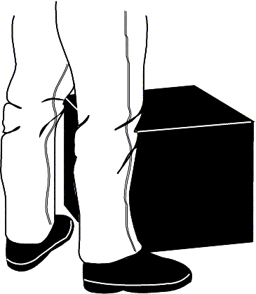Stand close to the load with your feet spread apart about shoulder width, with one foot slightly in front of the other for balance.
2. 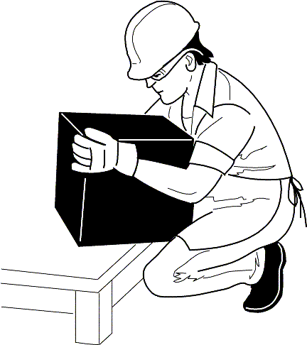Squat down bending at the knees (not your waist). Tuck your chin while keeping your back as vertical as possible.
3. Get a firm grasp of the object before beginning the lift.

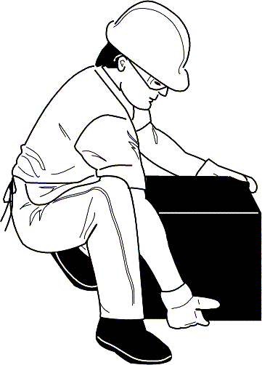

1. Begin slowly lifting with your LEGS by straightening them. Never twist your body during this step.
2. 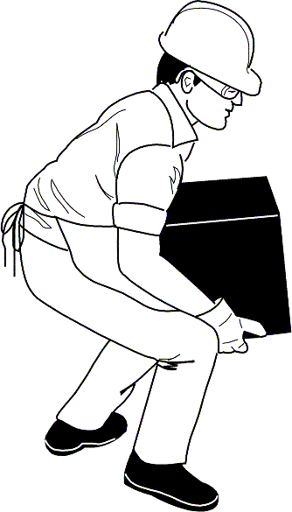Once the lift is complete, keep the object as close to the body as possible. As the load's centre of gravity moves away from the body, there is a dramatic increase in stress to the lumbar region of the back.

If you turn while carrying the load, turn using your feet-not your torso.

To place the object below the level of your waist, follow the same procedures in reverse order. Remember, keep your back as vertical as possible and bend at the knees.