First Aid Treatment Form |  |  |  |  |  |  |  | 1. Original to file  2. Copy to Nurse/Doctor/Ambulance  3. Copy to HSE Officer
Details of the person receiving treatment
Surname: Given Names: Date of Birth: Sex: M F
Status: Operational Worker:□ Office Worker:□ Contractor / Employed by Contractor:□ Visitor: □

Staff / Student: Number: Faculty/School/Division:
If staff: Job Title: Continuing: □ Casual: □ Supervisor:
If Contractor or employed by contractor: Name and address of Contractor: If Visitor: Address:

Details of the Illness/Injury
Date: and Time: am/pm Campus: F G M T W Other

Where did the event happen? Be specific, e.g. room and building

Witness (if appropriate)
History of Illness/Injury

Allergies |  |  |  |  | Medication
Observations | Time | Time | Time |  | Assessment
Level of Consciousness |  |  |  |  |  | 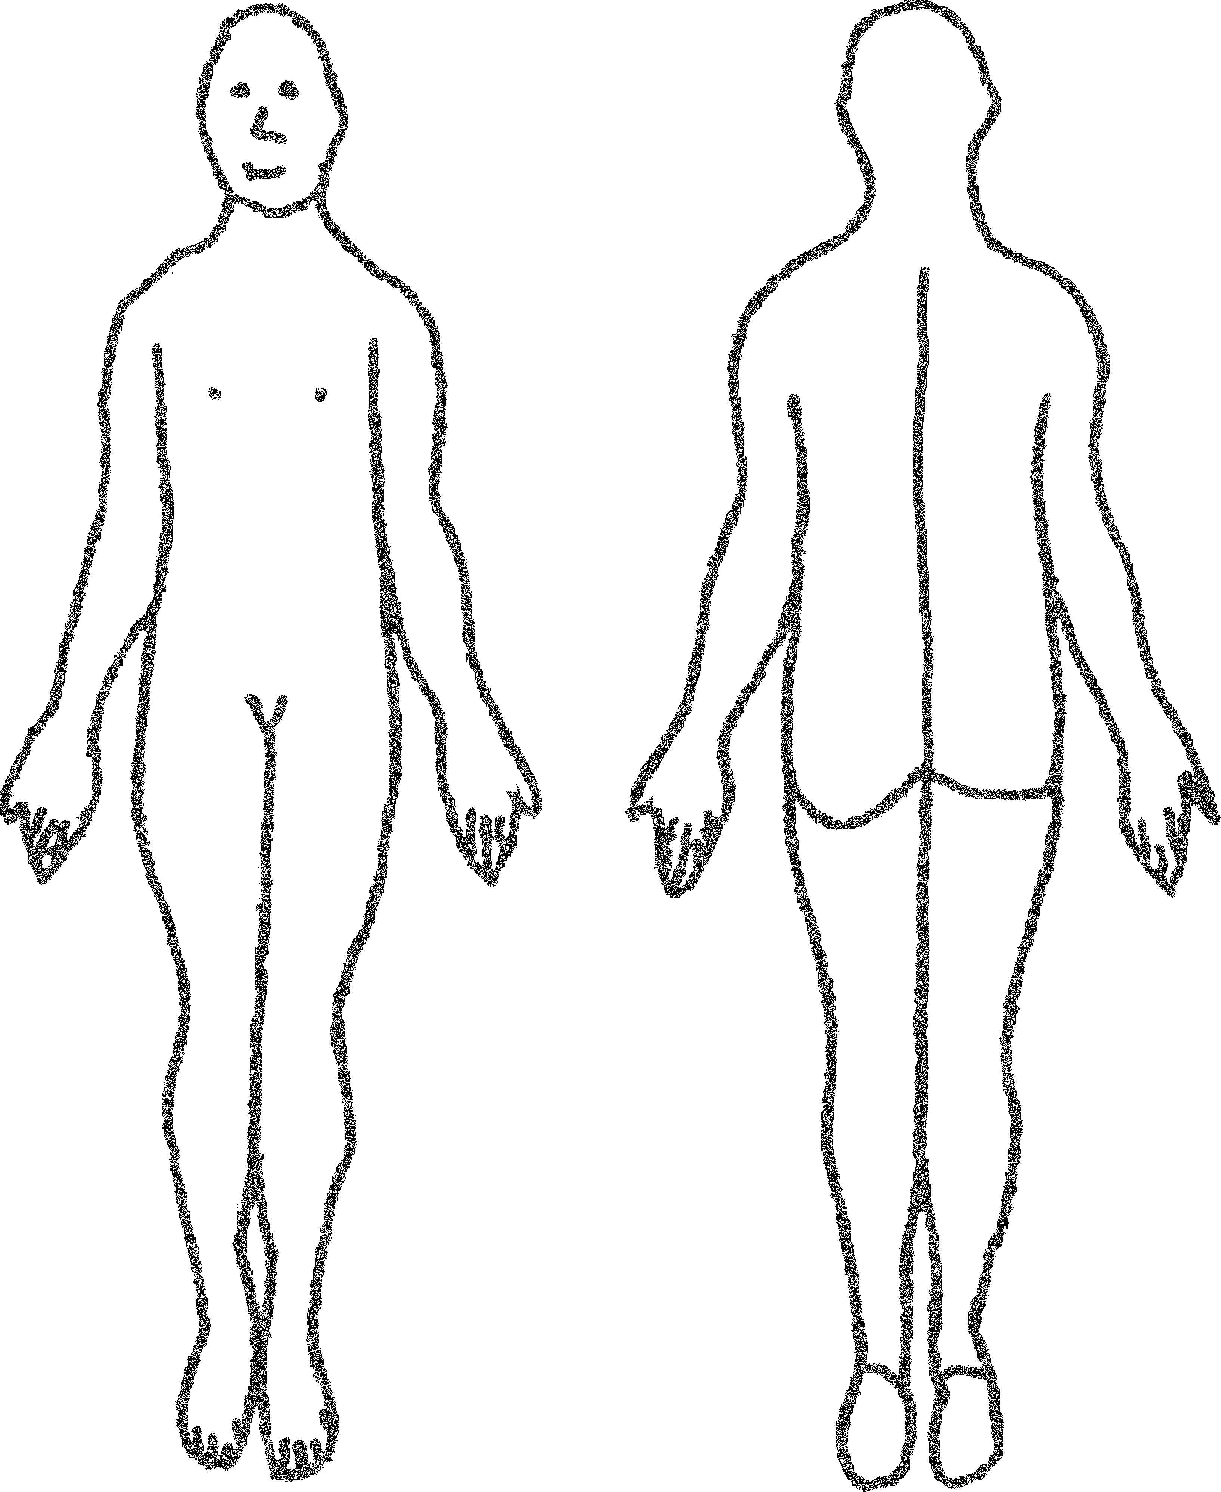
Fully Conscious |  |  |  |  | Abrasion
Drowsy |  |  |  |  | Burn
Unconscious |  |  |  |  | Contusion
Description |  |  |  |  | Deformity
Breathing |  |  |  |  | Fracture
Rate |  |  |  |  | Haemorrhage
Other |  |  |  |  | Laceration
Notes |  |  |  |  | Pain
Notes |  |  |  |  | Rigidity
Notes |  |  |  |  | Swelling
Notes |  |  |  |  | Tenderness
Assessment

Treatment

Follow Up/Referral - None □ Nurse □ Doctor □ Ambulance □ Hospital □ Other □
Outcome: Continued work/study□ Returned next day□ Absent more than 1 day□ Unknown □ Admitted to hospital? Yes □ No □
Comments

First Aider (Print):  Signature: |  |  |  | Time:  Date: |  |  | All accidents and workplace injuries should be reported by the person concerned to their supervisor and an Accident and Hazard Report completed.

